**Open Wrt update**

1. cloning submodule into the local repository

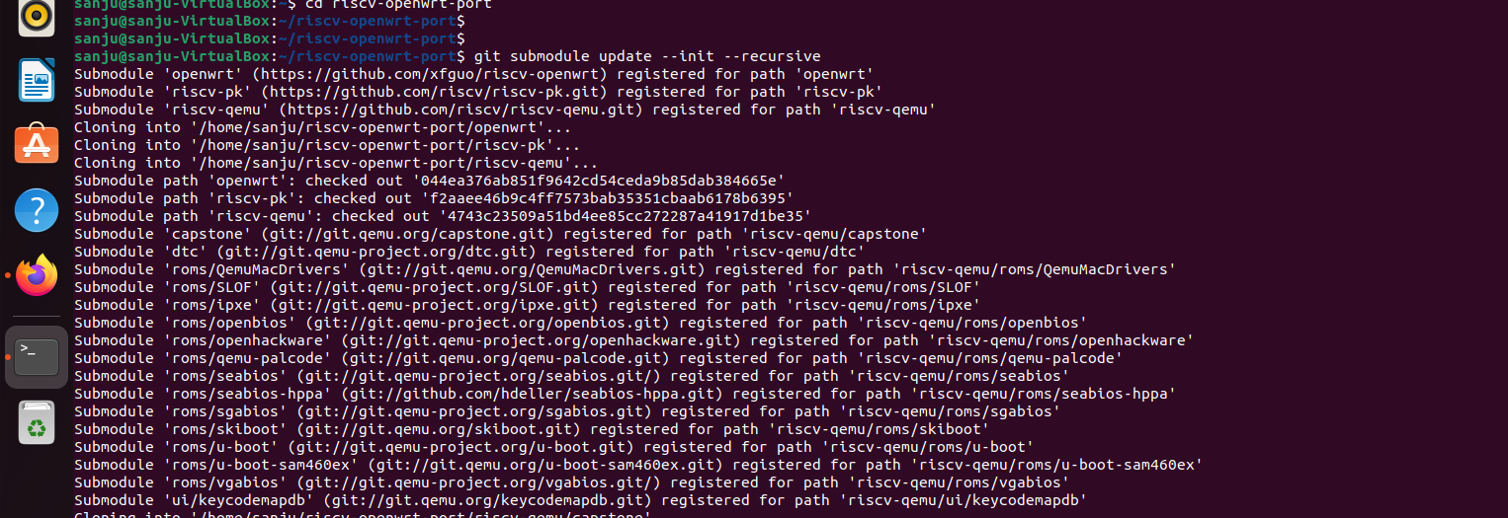

1. installation of essential libraries

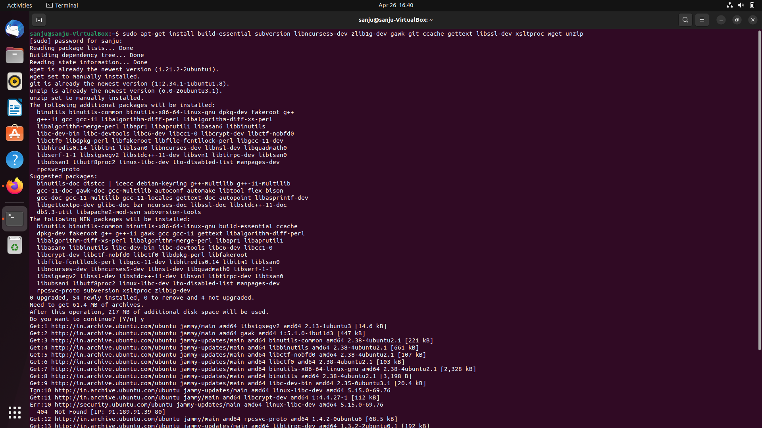

1. making an config file for target system

(by using the command make menuconfig)

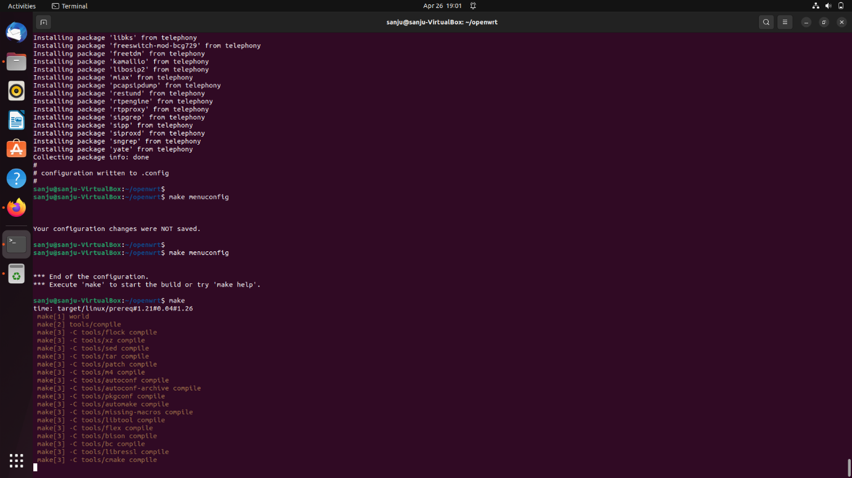

1. config menu will appear then

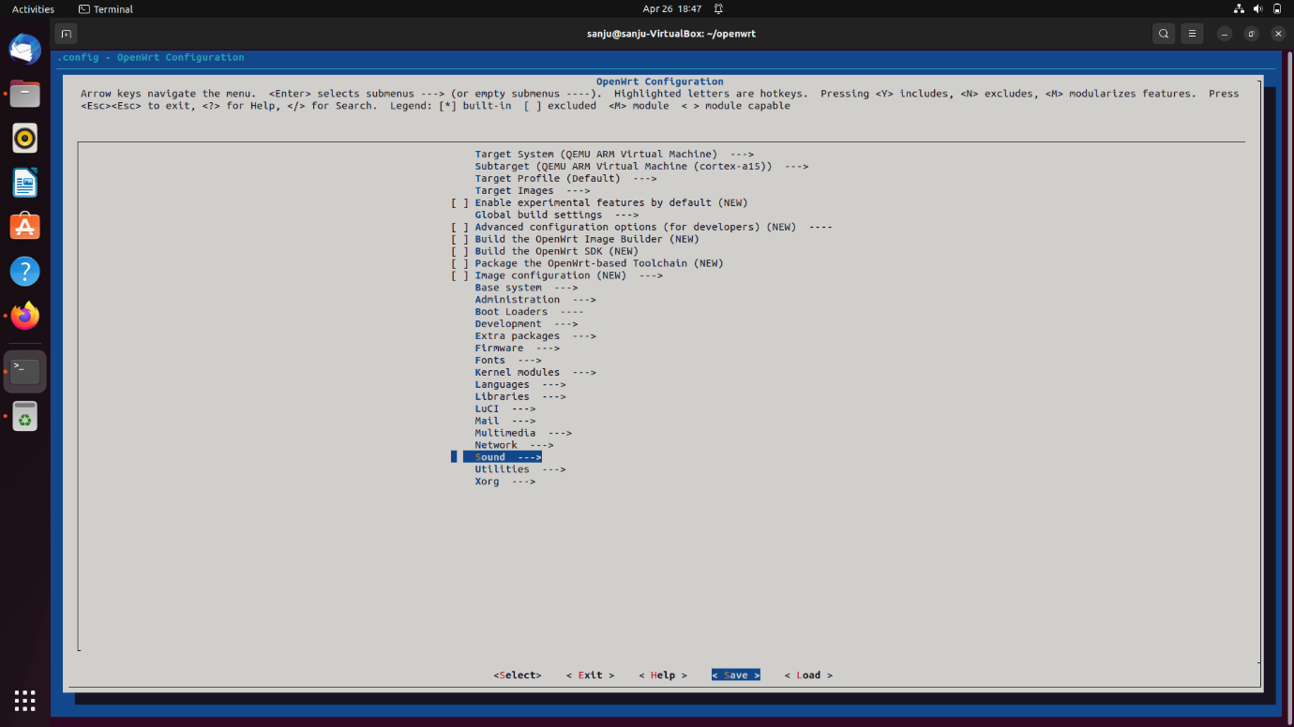

Choosen target machine as QEMU virtual machine

Then target system as x86 ( aslo tried with -atherox ATH79 etc)

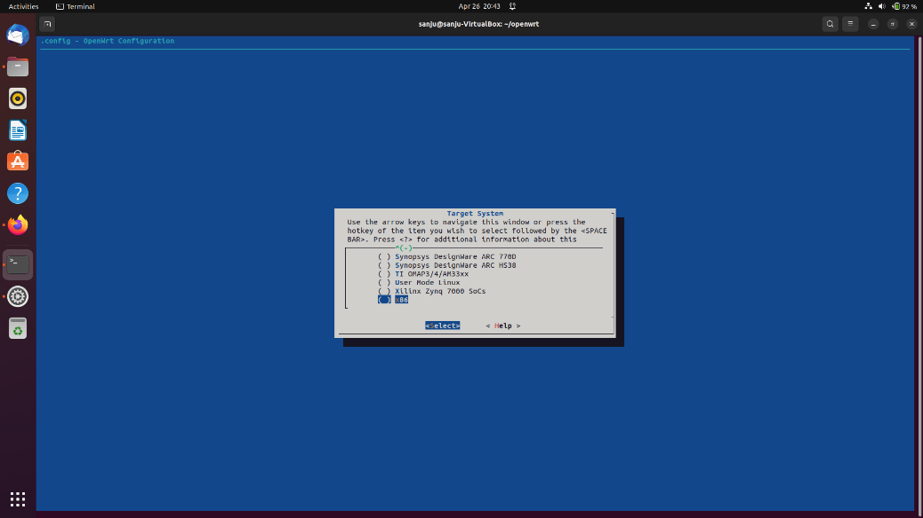

Then sub-target as generic

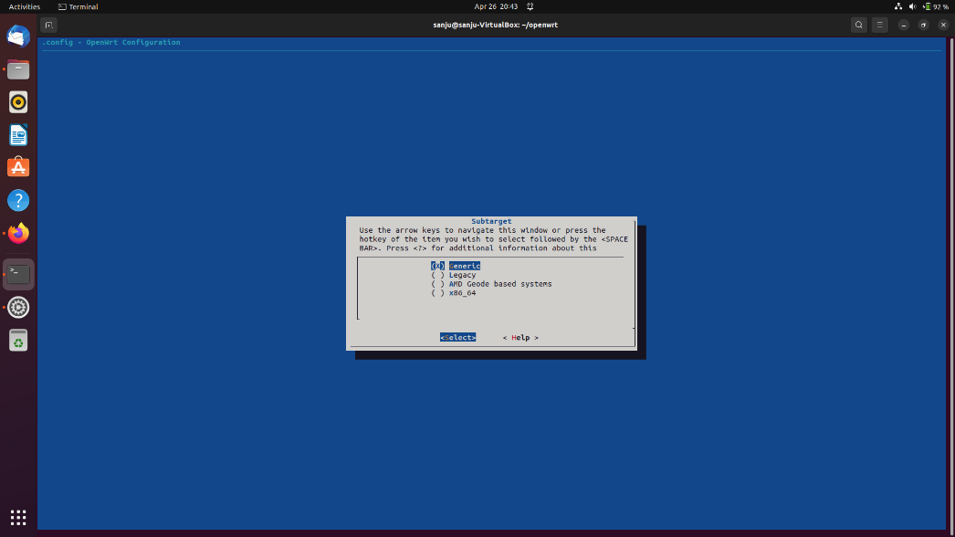

Named file as x86cnf.config

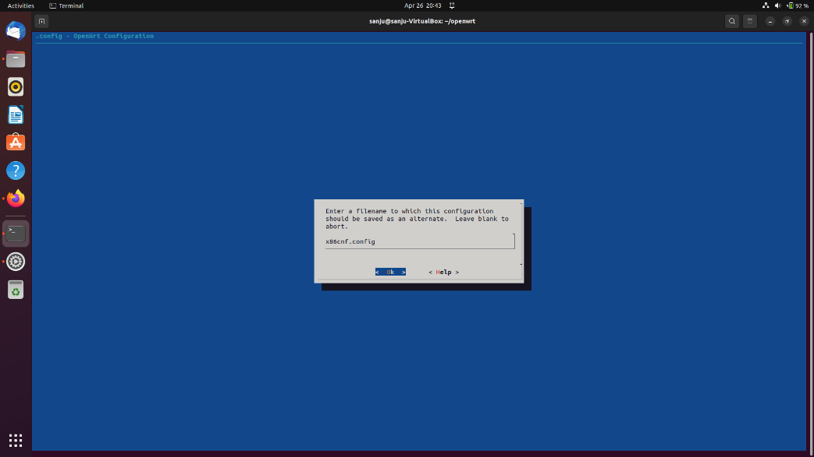

1. used **make** commnad to create an bootable image

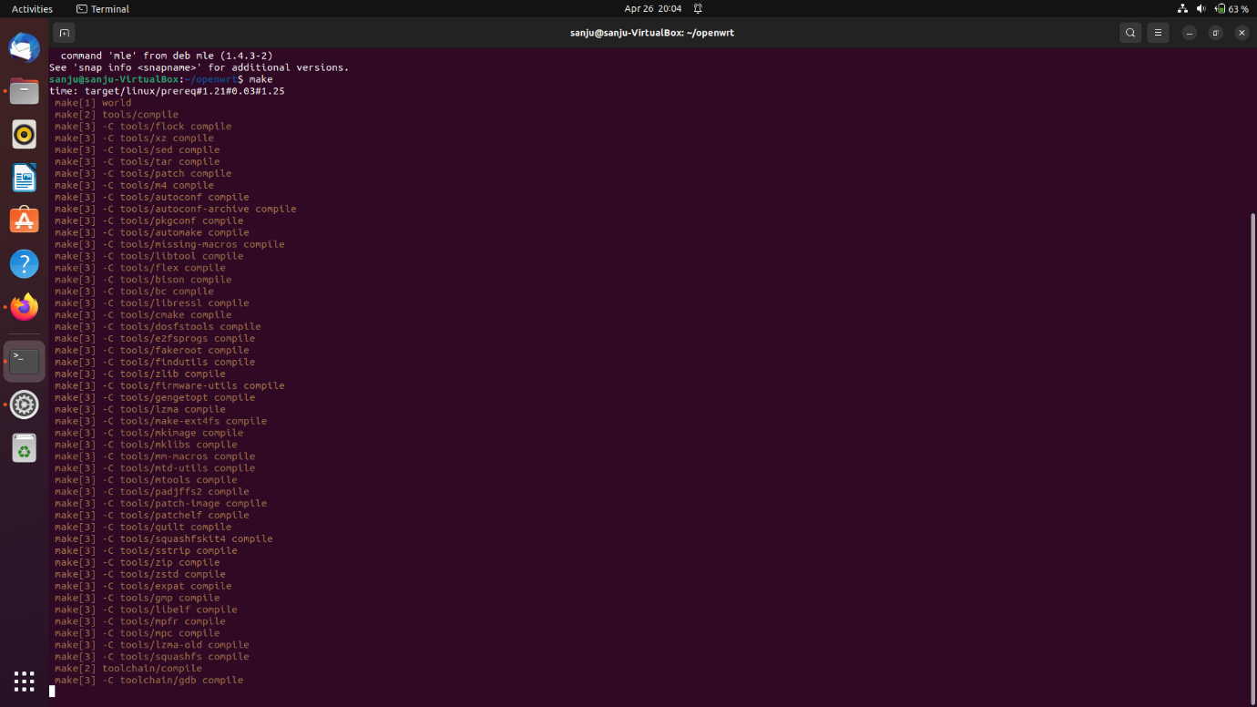

1. links to
   1. BSDMake file: <https://drive.google.com/file/d/1bgETXaLRa9Raqf6PqVkcP75ZBIoatgpk/view?usp=drive_web>
   2. Makefile : <https://drive.google.com/file/d/1d3hFKch2FPzkOhbJTsPnB5VBxdM1PWa3/view?usp=drive_web>
   3. Imagefile that has been obtained by the process: <https://drive.google.com/file/d/1WHFOJAkehSfUQIE48XQihdrdrShmllfs/view?usp=drive_web>

Ayush Sondhiya